minutes
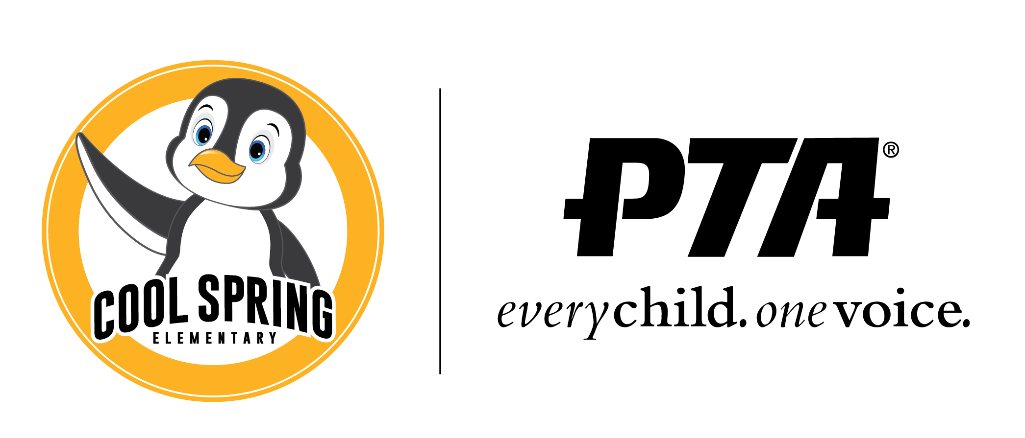
Cool Spring Elementary PTA Meeting
Tuesday, January 11, 2022, 6:30pm

Board members
Mindy Trzcinski, President | Jessica Huff, VP Fundraising | Nikki Maples-Reynolds, VP Communications | Samantha Whitehead, Treasurer | Eloise Simmonds, Secretary | Chris Cadwell, Principal
WELCOME!
12 people in attendance
Meeting Start: 6:31pm

- Welcome (Mindy Trzcinski) -
- Approval of the Minutes (Eloise Simmonds) – November Minutes are approved by Nikki and Mindy
- Officer Reports:
  - President’s Report (Mindy Trzcinski)
The playground has been officially ordered. It does take 8 weeks to come in. They are working on the best time to install the playground. In the case it is cold, they will house the playground in storage in their Ashburn location. The spongy surfacing needs to be added but need to be 40 degrees for at least 2 days to be put down. We will see what is happening in the spring to possibly have a ribbon cutting event.
Thank you to everyone who contributed to the winter staffing event. charcuterie boxes were given to the staff. The extra was put into the staff lounge.
98 students that we were able to help with our Angel/ Penguin tree.
  - Treasurer’s Report (Samantha Whitehead)
November 2021 : Playground savings account. $1.47. We transferred a little over $24,000 to the main account to send a check to the county of Loudoun for the playground. $30,500.00
December 2021 : Playground savings account $1.47, Main account, $39,716.51 with no change in the fund request which is $8,061.69
  - VP Fundraising (Jessica Huff)
Mindy and Tammy were able to get our banners up from our Sponsors. Waiting for some checks from sponsors. Thanks to everyone for their hard work.
  - VP Communication (Nikki Maples Reynolds)
Work on getting link up for upcoming events.
  - Principal’s Report (Chris Cadwell)
An update on the Vestibule enhancement. It will be an Early spring start on that. We will have to do some logistically changes to the front entrance when that starts. When we know for sure of the start date, we will let everyone know of the changes coming and going.
Thanks to family for their patience with the Covid protocols. Hopefully by spring we will get pass through this. Please keep us informed if there are changes in the home.
January 17th Martin Luther King Jr. Holiday.
January 18th – Instrument night at Harper Park Middle School for 5th graders that are moving on. Will be a virtual event. Information went out tonight for that.
January 18th – Pep meeting at 7pm which will be virtual.
January 19th – will be a Monday schedule.
January 28 – end of marking period
January 31 - Teacher workday.
February 1 – will be a holiday for staff and students. It is also Chinese New Year and the start of Black History Month.
- New Business
    - Minority Student Achievement Advisory Committee (MSAAC) Representative Report (Eloise Simmonds/ Nelly Arciniega Corona) – the next meeting will be January 19th issues impacting the homeless student population and the Latinx community.
    - Special Education Advisory Committee (SEAC) Representative Report (Dana Lankuf) – She will send us information through the Facebook page. If she has any other information, she will send over to Mr. Cadwell for Smores.
    - Potential changes to events due to current COVID Numbers
February 11 Sweetheart Dance – will be making a change to a virtual event. Looking into an online company run the event through zoom. Will have to check to see if the kids can access the event through the kids Chromebook. There will be 4 bingo games with some dance in between. There will also be 4 prices. It will be an hour and half long dance party and bingo event.
March 25th Talent Show - Will talk to Ms. Thompson about the talent show. That will not be a in person event. If the kids are interested, please look for details for that. We will work with Ms. Thompson on the best way how submissions will work.
We will send out the information through Smores and Member Hub.
We are holding off on cancelling events for now.
    - Report from LCPS Health Office with Q&As from recent mitigation procedure changes
It might be easier if we compile a list. Reached out to the Loudoun County Public School Health services. They did not have a chance to answer them.
- Who would be tracking the additional timeline for students and staff? Mr. Caldwell’s answer - We have an internal tracking spreadsheet for that.
- If you are a close contact and can show a booster or both shots of the vaccine in the last 6 months and is asymptomatic you do not have to quarantine for 5 days. If you should become symptomatic in those 5 days, should you quarantine for 5 days after that? – Mr. Caldwell’s answer – you will not have to quarantine if you do not show symptoms. The 5 days quarantine will start when the symptoms is present.
- Is the school providing a well-fitting mask? Who is charge in enforcing that for the additional 5-day period? Mr. Caldwell’s - Our guidance, everyone should have a good quality fitting mask that covers the nose and mouth.
- If my child has no dosage or got one dosage of the vaccine and then tested positive after. How long do I need to wait to get the shot?
- Where do my child fall on the chart if they have had Covid in the past 90 days and are asymptomatic? Mr. Cadwell’s answer: you do not have to quarantine unless you show symptoms.
- How are we implementing the new VDH expectation of 6 feet between kids while eating days 6-10 days after quarantining? Are they still allowed to have breakfast in the classroom? Mr. Caldwell’s answer – We implement 3 ft where possible. There are assigned seating for lunch in which we can track. They can still eat breakfast in the classroom.
If we can get clarity, Nikki can create a chart.

Mr. Cadwell comments: LCPS will not jump on every piece of guidance from the CDC. There will be some changes done to the flow chart based on the CDC revisions. Something will be coming soon. We are following what the county put out.
A draft will be sent to Mr. Cadwell and Mr. Cadwell can possibly answer some of the questions if they are specific to Cool Springs.

Want to thank Meagan Hill for the Pop tabs event.
8lbs of Pop tabs was collected. Kindergarten won the pop tab contest and the popcorn party. We will continue to collect pop tabs, but no prizes associated with it. She will drop the pop tabs to Ronald McDonald House.
Will discuss possibly doing it again next year around the same time as the Angel/ Penguin Tree.

    - QUESTIONS
- Adjourn 7:08pm
UPCOMING DATES

February 2022
Feb. 8 PTA Meeting, 6:30 PM Gym/Cafeteria
Feb. 11 Sweetheart Dance

March 2022
Mar. 8 PTA Meeting, 6:30 PM Gym/Cafeteria
Mar. 25 Talent Show

April 2022
April 1 Basketball Night @ Heritage High School
April 5 PTA Meeting, 6:30 PM Gym/Cafeteria

May 2022
May 1-7 Teacher Appreciation Week
May 10 PTA Meeting, 6:30 PM Gym/Cafeteria

June 2022
June 2-3 (6-7) Field Days: PK-2 on June 2, Gr. 3-5 on June 3, with June 6-7 Rain Dates
June 7 PTA Meeting, 6:30 PM Gym/Cafeteria

All the most current information always available on our website www.coolspringpta.org!
Contact us: coolspringpta@gmail.com

