MINUTES
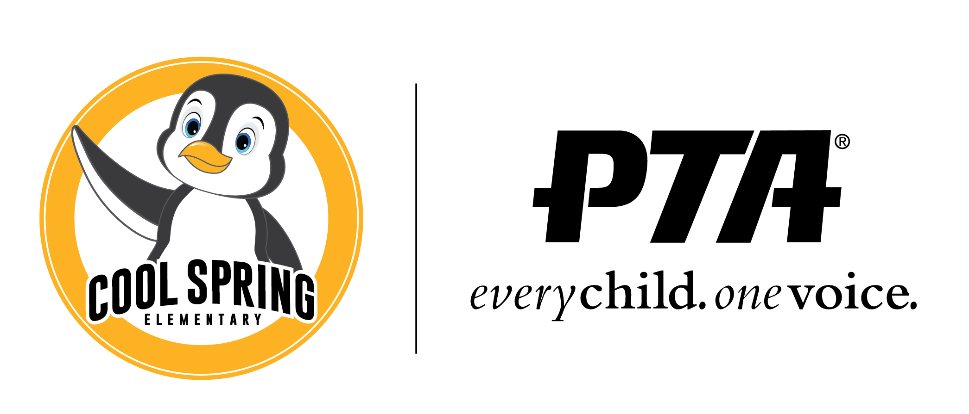
Cool Spring Elementary PTA Meeting
Tuesday, September 14, 2021| 6:30pm

Board members
Mindy Trzcinski, President | Jessica Huff, VP Fundraising | Nikki Maples-Reynolds, VP Communications | Samantha Whitehead, Treasurer | Eloise Simmonds, Secretary | Chris Cadwell, Principal
WELCOME!

- Welcome (Mindy Trzcinski)
- Introductions
- Officer Reports:
    - President (Mindy Trzcinski) – We are above the membership from last year. We are at 108, 17% of our school population. It is more than what we had at the end of last year.
    - Treasurer’s Report (Samantha Whitehead) –
Playground fund: starting at $24,708.29 and ended with $24,709.34 with little interest.
Business account: Started at $20,844.53 and ended with $20,891.30 including the fund requests.
Fund Requests - $9800
It will be different next month with the events coming up like Raise Craze.

    - VP Fundraising (Jessica Huff) – We have a couple of return sponsors this year, like Legacy Orthodontics, Ion, 5 Tara, Hancock to name a few. We reached out to 100 sponsors last year and got around $10K. Raise Craze is coming up. Provided a back story for Raise Craze. Why it is different from Boost a Thon Fun Run. With Bosst A Thon Fun Run, less money was kept as opposed to Raise Craze, we were able to keep more of the money around 91%. Raise Craze tracks acts of kindness. It kicks off on October 4th and will run for two weeks. The information will be in next week’s Thursday’s folders. Depending on how things work out we may have a pep rally or a video. Each grade level will have a charity project and family service night where families can do things together. After the two weeks, we will announce who had the top acts of kindness and funds raised by classroom and grade level. Trophies will be given out. We will need assistance so you can sign up to help.

    - VP Communication (Nikki Maples Reynolds) – Need help translating forms. Keep events updated a month in advance. Any suggestions will be helpful in getting the word out.

    - Principal’s Report (Chris Cadwell) – thank you to the parents and PTA. 573 current enrollment including new families. Have kids coming from all over the country and out of the country. Many families that left last year are back.
Safety Update: We are on the list for vestibule enhancements. The entrances will be replaced sometime this year. Once we know more, we will announce. We will be getting a front entrance monitor that the county will provide. They will not be armed security. They are there to watch the perimeter, checking doors, and checking in visitors.
Wednesday begins Hispanic Heritage Month. We will do things throughout the month to celebrate Hispanic Heritage Month.
Student Holiday will be this Thursday, September 15th.
September 27 & 28 will be vision and hearing screening. This will be for kindergarten, 3rd graders, and whoever is new.
September 28th - PEP – EL teachers run this program. This is designed to help families that are new to the US education system. Each month different topics is discussed. Also provide help to families with resources.
Picture day will be on October 13th.
Kiss and Ride times has improved. We have extra placards for families that need them.

- New Business
- Review of 2020-21 Budget/Audit (Mindy Trzcinski) – We completed our audit and quick review of last year. 57% of the money spent was on the playground. Large expenses spent on T-Shirts and favors. 680 shirts bought for students, and we purchased our own favors. Staff appreciation, staff lounge stocking. Parents contributions which helped with our budget this year. Fund Requests were around 4% of our budget. This is what we used to build our budget for this year. We used a program called money minders.
- Review & Vote of 2021-22 Budget (Samantha Whitehead) – below a list of items that are part of the budget.
Memberships
Fund Raising
Food Truck
Sponsors
Free Library
Vinyl Door Wrapping
Other events that will have expenses.
Bank Fees
Fund Requests – not just for teachers. Anyone that has good ideas and in good standing with the PTA.
*The budget has been approved by Mindy, Nikki, and Jess. *
- VOTE: Fund Request #1 – to purchase Amplifier speakers for the classrooms. 5 Amplifiers will be needed. The cost will be $179.00. * Fund request approved by Nikki and Jess. *
- VOTE: Fund Request #2 – Enhancing the bathrooms. Decals messages of positivity. Looking to install them during Raise Craze. It should be $750 but can cost $843.00. It should cover 38 decals. The cost will be finalized by Mr. Cadwell.
*Fund Request approved by Nikki and Jess. *
- Suggestions Parking Lot/ Kiss & Ride – heard a couple of suggestions to try to make the Kiss & Ride easier for families. An aerial view of the parking lot sent to suggest flipping the bus lanes switched to the car lanes. It was deemed not logical considering the space and safety. Another suggestion to get a sign to provide the 3 top rules of the Kiss & Ride.
- Questions -

- Adjourn: meeting ended at 7:32pm

UPCOMING DATES
September 2021
September 17 Family Game Night (Bingo, Kahoot)

October 2021
October 12 PTA Meeting, 6:30 PM Gym/Cafeteria
Oct. 4 - Oct.17 Raise Craze
October 14 Family Service Night @ Cool Spring

November 2021
November 9 PTA Meeting, 6:30 PM Gym/Cafeteria

December 2021
December 14 PTA Meeting, 6:30 PM Gym/Cafeteria (Paper Meeting if Needed)

January 2022
January 11 PTA Meeting, 6:30 PM Gym/Cafeteria

February 2022
Feb. 8 PTA Meeting, 6:30 PM Gym/Cafeteria
Feb. 11 Sweetheart Dance

March 2022
Mar. 8 PTA Meeting, 6:30 PM Gym/Cafeteria
Mar. 25 Talent Show

April 2022
April 5 PTA Meeting, 6:30 PM Gym/Cafeteria
April Basketball Night @ Heritage High School

May 2022
May 1-7 Teacher Appreciation Week
May 10 PTA Meeting, 6:30 PM Gym/Cafeteria

June 2022
June 2-3 (6-7) Field Days: PK-2 on June 2, Gr. 3-5 on June 3, with June 6-7 Rain Dates
June 7 PTA Meeting, 6:30 PM Gym/Cafeteria

All the most current information always available on our website www.coolspringpta.org!
Contact us: coolspringpta@gmail.com

