Minutes
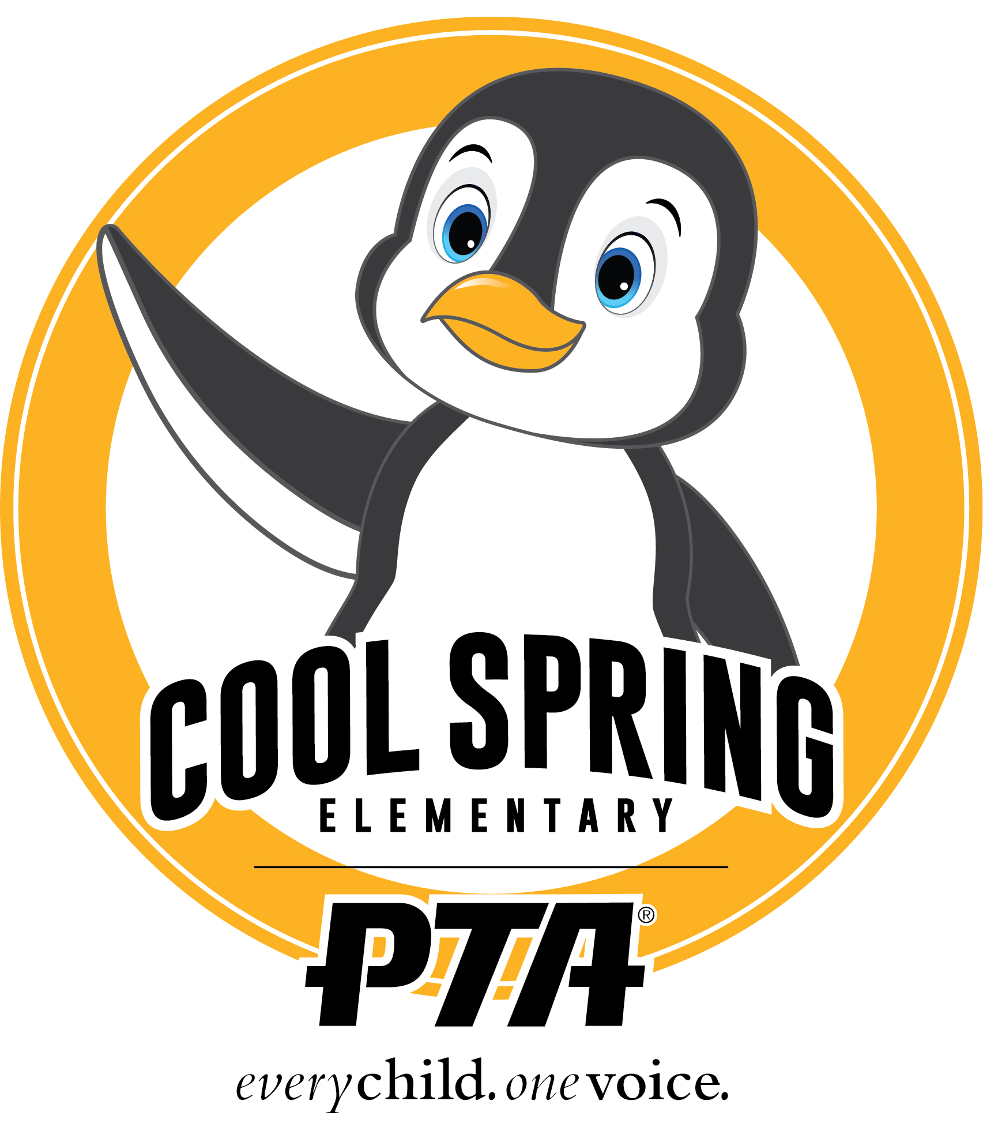
Cool Spring Elementary Executive Committee PTA Meeting
Tuesday, March 8. 2022| 5:30pm

Agenda Items:

- Call to Order Mindy Trzcinski, President

- Approval of Minutes from 2/8/2022 Meeting

- Financial Report Sam Whitehead, Treasurer
Main $30469.49
Fund Request $6715.36

- President’s Report : Mindy Trzcinski
-Talent Show Update: We have 41 participants registered; the show will be split into 2 for school viewing. Parents will receive an email with links for both shows.
-Playground Update: We are awaiting one more piece of equipment, and then the poured in place surfacing will be installed (weather permitting). We will need to stay off of the surface for 3-4 weeks depending on temperatures.
-5th Grade Committee Update/Basketball Night: The 5th Grade committee is working on collecting donated snacks to sell at the basketball game. We will be having one game, due to participation. The PTA will be collecting money at the game and via Memberhub(donations) to fund the End Of Year Celebration for 5th grade. We will be voting at the general meeting to add 5th grade committee as a line item.

- Officer Reports

- Old Business
  - Playground Ribbon Cutting: April 22 (Rain Date April 29)
  - Nominating Committee/Intent to Serve Forms: We will be seeking members willing to serve on the nominating committee. We also need a Board Representative (not the President) to serve as a liaison to the committee should they need help. Jess indicated she will not be retuning as Board Member next year- but has already identified at least one person interested in joining the Board. The current Board agreed that it is important to disseminate information about all offices to the membership, but also have a plan for what happens if no one steps into at a minimum the 3 required roles: President, Secretary and Treasurer.
  - Teacher Appreciation Week Plans:
Nikki is working on a Superhero Themed week worth of plans- more information to follow.
For soups: non-shared serving if at all is preferred.
Possibly do Anita’s breakfast one day-
Finalize Days/Dates to release SUG(s)

- New Business
  - VOTE: Purchasing Decals for Free Libraries- will email out pricing for executive vote once they arrive.
The board unanimously voted to support decals for the Free Library, price estimate to come.

- Adjourn

